**TURO Dimensional Model Snapshots  
Assignment – 2**

Name: Amit Sawant

* MySQL Workbench Dimensional Model Snapshot

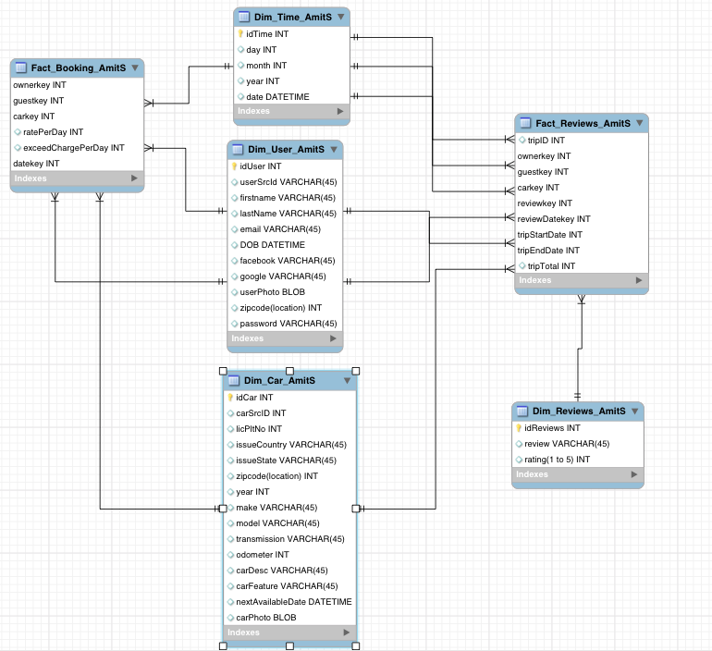

* Booking Fact Snapshot

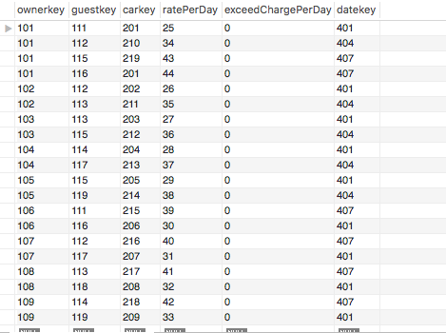

* Reviews Fact Snapshot

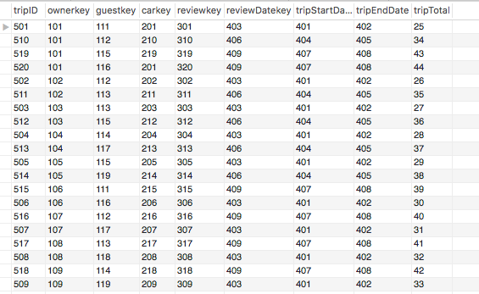

* User Dimension Snapshot

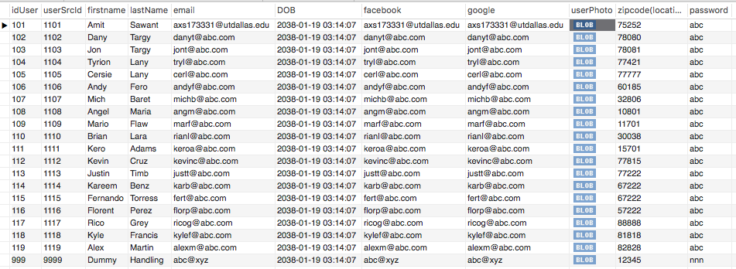

* Car Dimension Snapshot

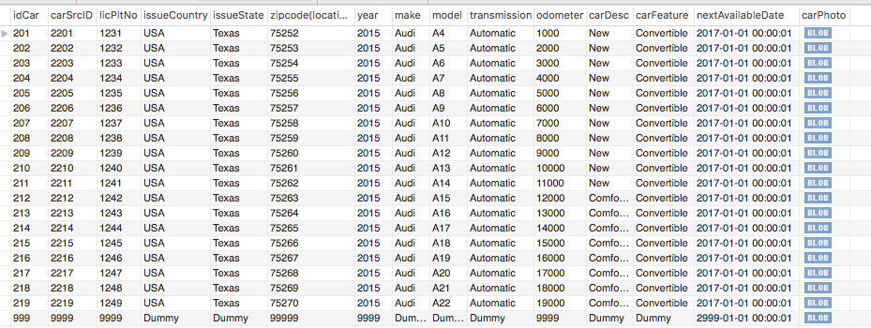

* Time Dimension Snapshot

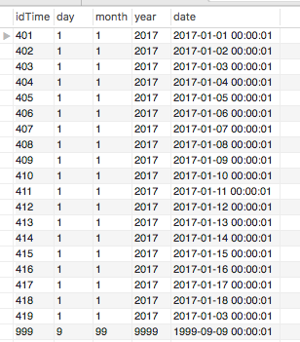

* Reviews Dimension Snapshot

